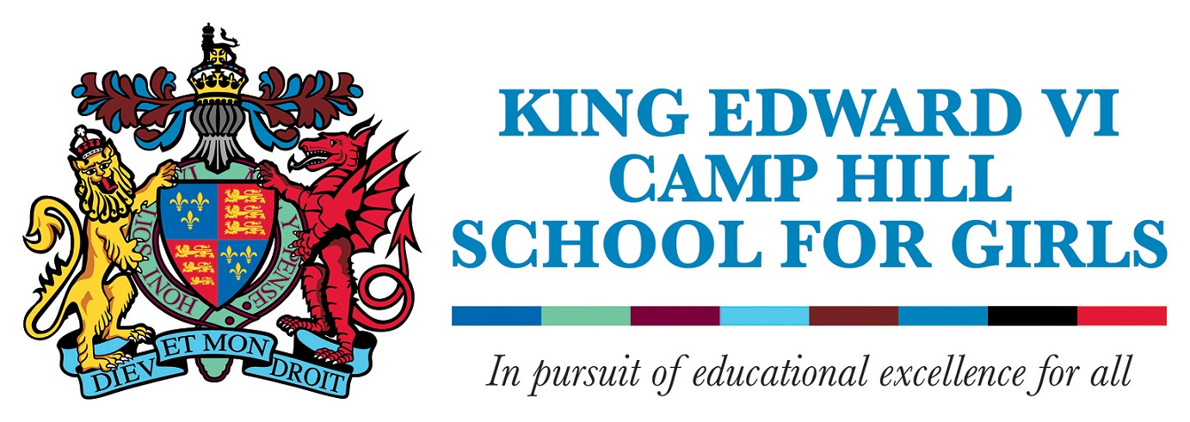

Non-Examined Assessment (NEA) & EPQ Appeals Policy

Deadlines for requests – 2024
31st March for GCSE English Language
26th April 2024 for all other subjects (except for Art)
10th May 2024 for GCSE and A Level Art
Candidate Name + Form | Candidate Number

Subject

Grounds for Appeal
Please note, your grounds for appeal cannot simply be because you feel you deserve a higher mark, or, your view on the quality of teaching. It needs to specifically relate to how you believe the mark scheme has not been applied correctly to your work.

Your work will later be subject to external moderation and you should be aware that during the moderation process, carried out by the awarding bodies, your mark may be changed to a higher or lower mark by the moderator.

The cost of this service is £50.00 and payment must be made via ParentPay at the time of handing this form to the Exams Office.

Candidate Signature_______________________ Date__________________ Paid____________

Date received by Examinations Officer________________________________________________

Action taken:

